**Project Design Phase-II**

**Data Flow Diagram & User Stories**

|  |  |
| --- | --- |
| Date | 15 October 2022 |
| Team ID | PNT2022TMID10909 |
| Project Name | A novel method for handwritten digit recognition system |
| Maximum Marks | 4 Marks |

**Data Flow Diagrams:**

A Data Flow Diagram (DFD) is a traditional visual representation of the information flows within a system. A neat and clear DFD can depict the right amount of the system requirement graphically. It shows how data enters and leaves the system, what changes the information, and where data is stored.

DFD Level 0 (Industry Standard) for Handwritten digit Recognition System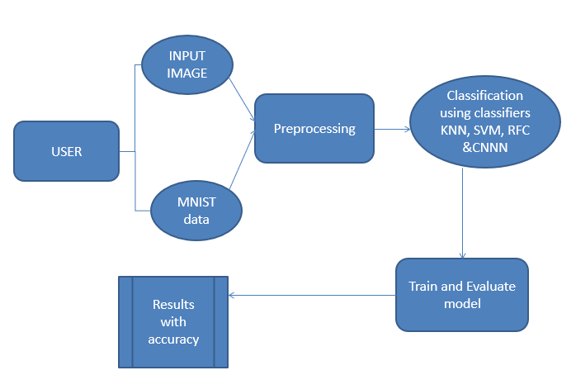

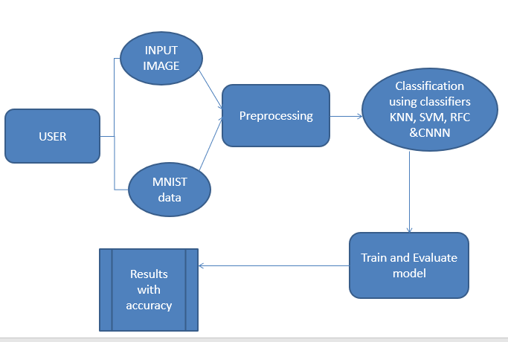

**User Stories**

Use the below template to list all the user stories for the product.

| **User Type** | **Functional Requirement (Epic)** | **User Story Number** | **User Story / Task** | **Acceptance criteria** | **Priority** | **Release** |
| --- | --- | --- | --- | --- | --- | --- |
| Customer (Mobile user) | Registration | USN-1 | As a user, I can register for the application by entering my email, password, and confirming my password. | I can access my account / dashboard | High | Sprint-1 |
|  | Confirmation | USN-2 | As a user, I will receive confirmation email once I have registered for the application | I can receive confirmation email & click confirm | High | Sprint-1 |
|  | Login | USN-3 | As a user, I can login into the application through email & password | I can login into the application through email & password | Medium | Sprint-1 |
|  | Dashboard | USN-4 | As a user, I can go to dashboard | I can access the dashboard | High | Sprint-1 |
| Customer (Web user) | Login | USN-1 | As a user, I can login the application using the registered email | I can access my account | High | Sprint-1 |
|  | Upload | USN-2 | As a user I can upload the handwritten digit | I can upload my image | High | Sprint-1 |
|  | Result | USN-3 | As a user I can get the recognized digit | I can view the output image | High | Sprint-1 |
| Customer Care Executive | Dashboard | USN-1 | As a user I can access the dashboard and send queries | I can send the queries and receive | High | Sprint-1 |
| Administrator | Security | USN-1 | As a administer I can access the user data | I can access data | Medium | Sprint-1 |